UNIT 4.2

THE COMPUTER SYSTEMS AND SOFTWARE
TUTOR NAME: MS. FATHIMA

SUBMITTED BY FATIMA EJAZ BARRI
TABLE OF CONTENTS
TASK 1.1 Describe components of different computer systems
TASK 1.3 Assess the function of components within a chosen computer system
TASK 2.2 Critically assess the use of different software applications to meet specific purposes
TASK 2.3 Assess the use of web applications to enhance user experience

- Describe the components of different computer systems
Computer components: definition
All the different pieces of electrical hardware that join to make up the complete computer system. Components from the complete system.
- Input devices (keyboard, mouse etc.)
- Output devices (monitor, speakers etc.)
- Secondary storage devices (hard disk drive, cd/DVD/drive etc.)
- Processor and primary storage devices (CPU,RAM)

- Input devices: Data and instructions must enter the computer system before any computation can be performed on the supplied data. The input unit that links the external environment with the computer system performs this task. Data and instructions enter input units in forms that depend upon the particular device used. For example, data is entered from a keyboard in a manner similar to typing, and this differs from the way in which data is entered through a mouse, which is another type of input device. However, regardless of the form in which they receive their inputs all input devices must provide a computer with data that are transformed into the binary codes that the primary memory of the computer is designed to accept. Units that called input interfaces accomplish this transformation. Input interfaces are designed to match the unique physical or electrical characteristics of input devices to the requirements of the computer system.
In short, an input device performs the following functions.
- It accepts (or reads) the list of instructions and data from the outside world.
- It converts these instructions and data in computer acceptable format.
- It supplies the converted instructions and data to the computer system for further processing.

- Output devices: the job output devices is just the reverse of that of an input unit. It supplied information and results of computation to the outside world. Thus, it links the computer with the external environment.as computers work with binary code; the results produced are also in the binary from. Hence, before suppling the results to the outside world, it must be converted to human acceptable (readable) form. Devices called output interfaces accomplish this task.

In short, an output device performs the following functions.
- It accepts the results produced by the computer, which are in coded form and hence cannot be easily understood by us.
- It converts these coded results to human acceptable (readable) form.
- It supplied the converted results to the outside world.

- Secondary storage devices: the data and instructions that are entered into the computer system through input units have to be stored inside the computer before the actual processing starts. Similarly, the results produced by the computer after processing must also be kept somewhere inside the computer system before being passed on to the output units. Moreover, the intermediate results produced by the computer must also be preserved for ongoing processing. The storage device or the primary storage of a computer system is designed to do all these things. It provides space for storing data and instructions, space for intermediate results and space for the results.
In short, the specific functions of the storage unit are to store:
- All the data to be processed and the instruction required for processing (received from input devices).
- Intermediate results of processing.
- Results of processing before these results are released to an output device.

- Processor and primary storage devices:
The system unit is the core of a computer system and the main processing centre. Usually a rectangular box holds many electronic components that process information. The most important part of these components is the central processing unit (CPU) also called the processor. The CPU is the brain of your computer it is the key component in interpreting computer program instructions and processes data. The next most critical element of a processing is RAM, often referred to as "primary storage" or "main memory". Random Access Memory (RAM) temporarily stores information that the CPU uses while the computer is on and is erased when the computer is turned off. A primary storage device is a medium that holds memory for short periods while a computer is running. Although it has a much lower access time and faster performance, it is also about two orders of magnitude more costly than secondary storage. Ram (random access memory) and cache are both examples of a primary storage device. Primary storage’s key difference from the others are that it is directly accessible by the CPU, it is volatile and it is non-removable.
In short, the functions of processor and primary storage devices are:
- The processor processes information and data and interprets it to help perform different functions.
- The primary storage device store information and data for a short period.

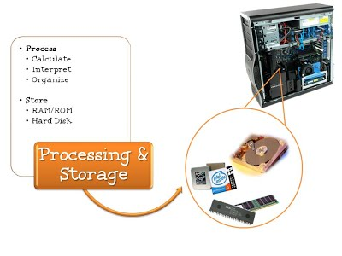

Example of Input devices
- Keyboard
- Mouse
- Touchpad
- Scanner
- Digital Camera
- Microphone
- Joystick
- Graphic Tablet
- Touch Screen
- Webcam
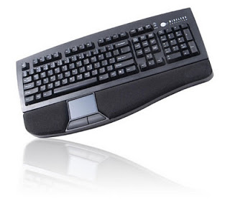
- Keyboard: A keyboard is the most common input device. Generally, standard keyboard has 104 keys. It is the primary input device.it uses a cursor to keep your place on the screen and to let you know where to begin typing.

Mouse: A mouse is an electro mechanical, hand held device.it is used as a pointer.it can perform functions like selecting menu commands moving icons, resizing windows, starting programs and choosing options. Functional device to move the cursor around the computer screen.
A mouse is a pointing device. It usually contains one, two or three button as the user rolls it on a flat surface, the mouse controls cursor movement on the screen. When the user presses one of the buttons, the mouse either marks a place on the screen or makes selections from the data on the screen. It can be used for many applications ranging from games to designing products with graphics. It can be used as an alternative to keyboard or it can be used in combination with a keyboard to enhance input operations.
TYPES OF MOUSE
1. Traditional mouse
Traditional computer mouse button will be the most affordable, when they make use of a simple construction. They connect to your personal machine utilizing the mouse port, and some mouse for Apple computers use a USB connection. Most mouse include a USB connection for those who love the USB port within the mouse port.
No special application is needed, while you need to reboot after connecting in case you are employing an older version of Windows. This kind of mouse does need to be periodically disassembled for cleaning. You should make use of a lint-free, static-free cloth for cleaning. It will eliminate harm to your mouse preventing any bothersome lint buildup.
2. Optical mouse
Optical mouse have become more commonplace. They exercise efficiently, because they lack the ball found in traditional mouse. The majority are built to be ergonomic, so you are able to make use of them very comfortably.
These mouse are less vulnerable to collecting dust than traditional mouse are and require less cleaning. Most optical mouse hooks up to your computer through the USB port. Special software usually isn’t necessary if you do not need advanced functions enabled for the mouse. You are able to enable any special functions that you want your mouse to accomplish when using the driver CD that had the mouse.
3. Wireless mouse
Wireless mouse provide capability of connecting without cables. That is very useful for gamers as well as others who want room to freely move their mouse. Some newer laptops consist of built-in infrared ports where you can start employing the mouse without special hardware.
These sorts of mouse include the necessary driver software. You’ll normally be capable to start using your brand-new mouse during first minutes. Wireless mouse are optical, taking into account easier movement. Many wireless mouse are purchased plus a wireless keyboard. When you’ve got a large enough monitor, you are able to safely sit well back through the computer and still have the capacity to apply it efficiently.

4. Laptop mouse
Laptop mouse have numerous of identical features as desktop mouse. They give a more compact design that is well suited to smaller spaces that laptops are utilized in. These mouse are ideal for laptop users unaccustomed to track pads. Additionally they are useful if your track pad fails and you possess zero chance to change it instantly. Laptop mouse use a retractable cord having a USB connection or may include wireless connection.

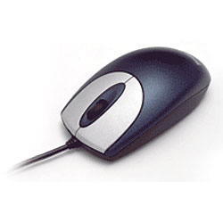

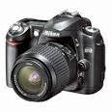
- Digital camera: it connects to the computer and transmits the images it captures. It can be photos or video. Later the photos are on the computer; they can be edited or printed.

- Scanner: Scanner is an input device, which works more like a photocopy machine. It is used when some information is available on paper and it is to be transferred to the hard disk of the computer for further manipulation.
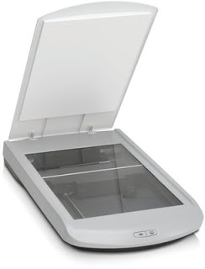

- Microphone: This input device has the ability to transform acoustic energy into electrical energy. This allows recording, storage, transmission and electronic processing of the audio signals. Thus, the microphone allows users to engage in voice conversations through their computer equipment.

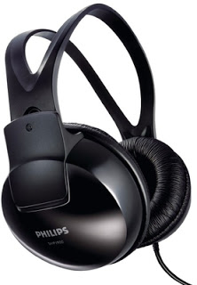

- Joystick: a pointing device that is used very often in computer games, although it is also common in industrial applications to handle devices.
- Graphic Tablet:

- Assess the function of components within a chosen computer system

